14.86: a) 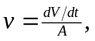 so the speeds are

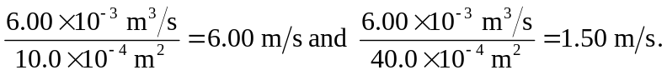

b) to three figures.
c) 